**MPE PTA EVENT RECAP FORM**

Committee Chair/Co-Chair are to submit a copy of completed form to PTA President no later than 2 weeks after event. Include as many details as possible! Send to [president@PTAMossPark.com](mailto:president@PTAMossPark.com)

**EVENT NAME: Grandparents Day**

**Brief Description of Event:**

**Event Dates & Times: September 5th, 6pm in cafeteria**

**Event Chair: Carrie Howard & Lis Sampson**

**Phone: 407-454-3950 (Lis) Email: lis@cloudspace.com**

**Proposed Budget: $500 Suggested Future Budget**

**Total Income: n/a**

**Total Expenses: $479.23**

**Total Profit (if intended): $ n/a Project Profit: n/a**

**Event Details:**

This was the first year holding this event in the evening instead of during the school day. We hoped this will be easier for everyone to park and attend. We also choose this because some kids have been sad in the past if their grandparents can’t attend plus it can be a disruption for the teachers and staff. Due to limited capacity in the cafeteria – we are asked that just the grandparents and the grandkids attend. We mentioned that a parent may need to attend as well to assist either the grandparent or the grandchildren if they are young – but to limit attendance to just one parent if needed. We let parents know that they could also wait in the lobby area if needed – but we really wanted to make sure we had enough room for all of our grandparents to attend. Because we did this event in the evening rather than daytime, the grandparents did miss out on getting a tour of their grandkid’s classroom and meeting the teacher.

We explored providing each grandparent a flower. Publix had little bunches of mini carnations 3 for $12 and there were 8 stems in the bunch that we looked at. That would mean in 3 bunches there would be 24 stems for $12 which is .50 per stem. We ended up spending about $80 at Publix for the carnations. The manager I spoke to was going to have the floral manager contact their whole sale florist to see if they could get them even cheaper for us. He is checking but thinks that if we ordered on Wed am he could get the flowers to us by Friday – but they will confirm this as well. We also discussed doing something specific for the grandfathers but couldn’t figure out anything that we could do quickly and cost effectively. We handed out the carnations as the grandparent’s entered the cafeteria.

Dr Cantrell did a quick talk to the grandparents and then the Voices kids performed a song.

Next we showed a power point that was originally made by Principal Moss and I think she interviewed the kids – maybe 3- 4 yrs ago. Last year Suzanne kept the comments and just removed the kids names and we kept it the same. Below are the old comments (the slideshow was 10 MG). We discussed updating it with newer quotes but ran out of time.

Below are some of the quotes:

Grandparents have glasses

My grandparent buys me toys

My grandma loves me

She is fat and nice

He doesn’t have hair

My grandma has white hair

Grandma takes care of me when mommy is at work

My grandma is old and grandfather is old too

Grandma is friendly and skinny

My grandma is helpful and pretty

My grandma is sweet

My grandma wears different clothes

My Grandma talks Spanish

My grandpa is nice

My Grandma is wrinkly

My Grandpa put my shoe in his ear

My grandpa is forgetful

My grandpa makes funny faces

My grandma likes to talk on the phone

And watches tv

My grandma takes me places

My Grandma makes cookies

My Grandma cleans my room

My Grandma is the only one who makes homemade food

I have 2 grandmas . . . one lives in the low house and one on top of the building!

Nana takes me places

My Grandma hugs me when she wants

I like my grandma – I met her when I was a baby

We purchased 10 half sheet cakes from Costco at $17.99 per cake. They said that it serves 48 people. We choose one cake with a balloon/birthday theme to present to Dr Cantrell as it was his birthday. We were supposed to get 5 chocolates & 5 vanilla cakes but a mistake was made and they ended up being all vanilla. We can get a ton of different decorations including school colors. We choose a 'scored rosebud' design without any words so we know where to cut. Lastly they need 48 hours notice when we order. We had a lot of cake left over at the end of the night.

We also served coffee and lemonade. We also got water bottles from ALDI. 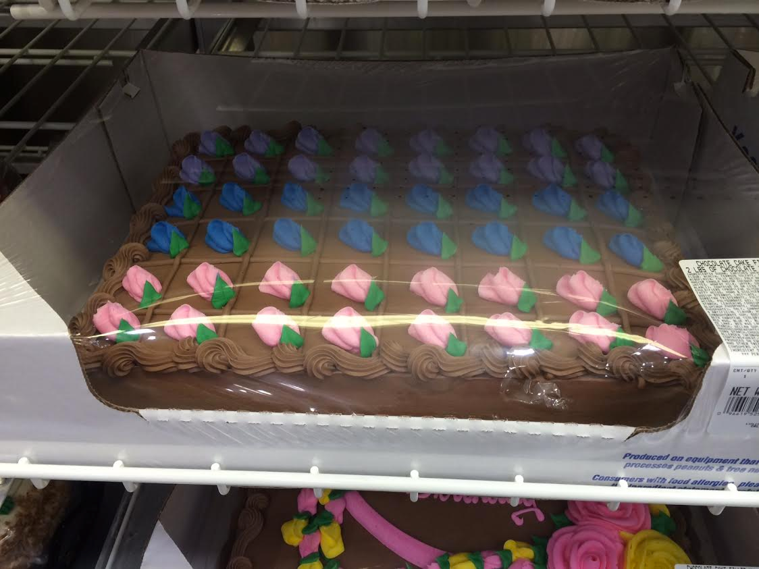

The activity we set up was a questionnaire for the kids to fill out about their grandparents with an area to draw a picture of the grandparent. We discussed a lot of options but were hesitant to do a project that was messy, complicated or would take a lot of time. Crayons were provided by Outback - 200 small boxes of 3 crayons. Some of the boxes had grease spots.

We set up a table near the lunch line entrance so entice grandparents to sign up for PTA or give to the pledge drive. The cake and drink tables were along the back of the cafeteria across from the stage. We had 1-2 volunteers per table so around 8 volunteers in total.

It was suggested that next year we do this event earlier in the day (around 4pm) in case people were uncomfortable driving in the dark.